17. Scenario: You are a data analyst working for a marketing research company. Your team has

collected a large dataset containing customer feedback from various social media platforms. The

dataset consists of thousands of text entries, and your task is to develop a Python program to

analyze the frequency distribution of words in this dataset. Your program should be able to perform

the following tasks:

Load the dataset from a CSV file (data.csv) containing a single column named "feedback"

with each row representing a customer comment.

Preprocess the text data by removing punctuation, converting all text to lowercase, and

eliminating any stop words (common words like "the," "and," "is," etc. that don't carry

significant meaning).

Calculate the frequency distribution of words in the preprocessed dataset.

Display the top N most frequent words and their corresponding frequencies, where N is

provided as user input.

Plot a bar graph to visualize the top N most frequent words and their frequencies.

Question: Create a Python program that fulfills these requirements and helps your team gain

insights from the customer feedback data.

Code:

**import** pandas **as** pd

**import** string

**import** matplotlib.pyplot **as** plt

**from** collections **import** Counter

**import** re

**import** os

stop_words **=** {

'the', 'is', 'and', 'in', 'to', 'with', 'a', 'for', 'of', 'on', 'it', 'this',

'that', 'i', 'was', 'but', 'be', 'have', 'not', 'are', 'as', 'very', 'so', 'from'

}

file_path **=** os.path.join(r"C:\Users\vara prasad\Downloads\data (1).csv")

**def** load_data(filepath):

**try**:

df **=** pd.read_csv(filepath)

**return** df['feedback'].dropna().astype(str)

**except** Exception **as** e:

print("Error loading file:", e)

**return** pd.Series()

**def** preprocess(texts):

words **=** []

**for** text **in** texts:

text **=** text.lower()

text **=** re.sub(f"[{string.punctuation}]", "", text)

tokens **=** text.split()

tokens **=** [word **for** word **in** tokens **if** word **not** **in** stop_words]

words.extend(tokens)

**return** words

**def** plot_words(word_freq, n):

common **=** word_freq.most_common(n)

words, counts **=** zip(**\***common)

plt.figure(figsize**=**(8,3 ))

plt.bar(words, counts, color**=**'orange')

plt.title(f"Top {n} Most Frequent Words")

plt.xlabel("Words")

plt.ylabel("Frequency")

plt.xticks(rotation**=**45)

plt.tight_layout()

plt.show()

**def** main():

feedback_data **=** load_data(file_path)

**if** feedback_data.empty:

print("No feedback data found.")

**return**

words **=** preprocess(feedback_data)

word_freq **=** Counter(words)

**try**:

n **=** int(input("Enter the number of top frequent words to display: "))

**except** ValueError:

print("Please enter a valid number.")

**return**

print(f"\nTop {n} Most Frequent Words:")

**for** word, count **in** word_freq.most_common(n):

print(f"{word}: {count}")

plot_words(word_freq, n)

**if** __name__ **==** "__main__":

main()

output:

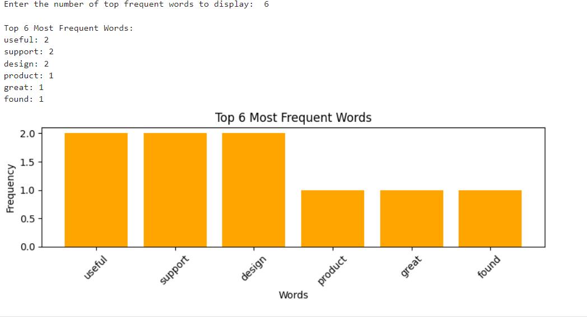

Dataset:

|  |  |  |  |  |
| --- | --- | --- | --- | --- |
| feedback |  |  |  |  |
| I love this product! Itâ€™s amazing and easy to use. | | | | |
| Terrible service. I will not buy from here again. | | | | |
| Good value for money. Highly recommended! | | | | |
| The product is okay, but delivery was slow. | | | |  |
| Excellent customer support. Very helpful and friendly. | | | | |
| Not satisfied with the quality. Could be better. | | | | |
| This is the best purchase I have made this year. | | | | |
| Poor packaging. The item was damaged on arrival. | | | | |
| Great experience overall. Will shop again! | | | |  |
| Average product. Nothing special, but not bad either. | | | | |